West Area Planning Committee | - 14th September 2011

Application Number: | 11/02020/EXT
Decision Due by: | 26th September 2011
Proposal: | Application to extend planning permission 08/01382/FUL for demolition of frontage buildings of 61/63 Cowley Road. Retention of rear workshop/store and 59 Cowley Road. Erection of 4 storey building (with basement) and conversion of workshop/store and No.59, to provide 2 shop units on ground floor and 5 flats above (2x2, 2x3, 1x1 bed), with private terrace, communal garden and refuse/recycling/cycle parking store (for 13 bicycles).
Site Address: | 59-63 Cowley Road (Appendix 1)
Ward: | St Clement's Ward

Agent: | Original Field Of Architecture | Applicant: | RTH Holdings

Recommendation: The West Area Planning Committee is recommended to be grant planning permission for the following reasons:

1 The principle of redeveloping the application site was established by the previous planning permission reference 08/01382/FUL. This application seeks to extend the permission and in the light of there having been no changes to the policy context or other circumstances the proposals remain appropriate and in accordance with the policies of the Oxford Local Plan and the Oxford Core Strategy.

2 Officers have considered carefully all objections to these proposals. Officers have come to the view, for the detailed reasons set out in the officers report, that the objections do not amount, individually or cumulatively, to a reason for refusal and that all the issues that have been raised have been adequately addressed and the relevant bodies consulted.

3 The Council considers that the proposal accords with the policies of the development plan as summarised below. It has taken into consideration all other material matters, including matters raised in response to consultation and publicity. Any material harm that the development would otherwise give rise to can be offset by the conditions imposed.

Conditions:
1 Development begun within time limit
2 Develop in accordance with approved plans
3 Samples
4 Variation of Road Traffic Order
5 Landscape plan required
6 Landscaping prior to occupation
7 Details of privacy screens and obscure glass
8 Bin and cycle storage

Main Local Plan Policies:
Oxford Local Plan 2001-2016 (OLP)
CP1 - Development Proposals
CP6 - Efficient Use of Land & Density
CP8 - Design Development to Relate to its Context
CP9 - Creating Successful New Places
CP10 - Siting Development to Meet Functional Needs
RC5 - Secondary Shopping Frontage
HS11 - Sub-Division of Dwellings
HS19 - Privacy & Amenity
HS20 - Local Residential Environment
HS21 - Private Open Space
TR3 - Car Parking Standards
TR4 - Pedestrian & Cycle Facilities

Oxford Core Strategy 2026
CS1_ - Hierarchy of centres
CS2_ - Previously developed and greenfield land
CS18 - Urban design, town character, historic environment
CS23_ - Mix of housing
CS31_ - Retail

Other Material Considerations:
PPS 1 – Delivering Sustainable Development
PPS 3 – Housing
PPS 4 – Planning for Sustainable Economic Growth
PPG 13 – Transport
Regional Spatial Strategy for the South East
Balance of Dwellings Supplementary Planning Document
Parking Standards Supplementary Planning Document

Relevant Site History:
08/01382/FUL - Demolition of frontage buildings of 61/63 Cowley Road. Retention of rear workshop/store and 59 Cowley Road. Erection of 4 storey building (with basement) and conversion of workshop/store and No.59, to provide 2 shop units on ground floor and 5 flats above (2x2, 2x3, 1x1 bed), with private terrace, communal garden and refuse/recycling/cycle parking store (for 13 bicycles) – allowed on appeal
07/02568/FUL: Demolition of frontage buildings of 61/63 Cowley Road. Retention of rear workshop/store and 59 Cowley Road. Erection of 4 storey building (with basement) and conversion of workshop/store and No.59, to provide 2 shop units on ground floor and 6 flats above (5x1, 1x2 bed), with courtyard garden and refuse/recycling/cycle parking store (for 16 bicycles) – refused

Representations Received:

Statutory and Internal Consultees:
Highway Authority – No objection subject to a condition to remove the site from the Controlled Parking Zone and provide cycle parking

Thames Water – No objection

Third Parties
One letter of comment has been received, the issues can be summarised as follows:

- Application refused in 2008. Needs fresh consideration
- Four storey building would not sit well with surroundings
- Support 13 cycle parking spaces
- Car parking will be issue

Officers Assessment:

Site description and proposal:

- The application site comprises No 59-63 Cowley Road, a part three storey (no. 59) and part two storey building (nos. 61 and 63). The building includes a mix of uses, with the ground floor level comprising a retail unit and its ancillary storage to the rear and on the first floor over nos. 61 and 63. A two bed flat accessed from Cowley Road is located above no. 59.

- The site is located on the northern side of Cowley Road between the junctions of Tyndale Road and Alma Place. It is within the Secondary Shopping Frontage and therefore the main frontage along Cowley Road is typified by commercial uses at ground floor level with residential or storage above. The side roads are generally in residential in use.

- Planning permission is sought to extend the consent granted on appeal in 2009 for the demolition of the frontage buildings of 61/63 Cowley Road and the erection of a 4-storey building (with basement) and refurbishment of the retained part of the building to provide 2 retail units on the ground floor and 5 flats at 1st, 2nd and 3rd floor level (comprising 2x3, 2x2 and 1x1 bed flats). The proposals also include private terraces, a communal garden and refuse/recycling storage and cycle parking to the rear. The officers’ report to committee is attached as Appendix 2 and the appeal decision is attached as Appendix 3.

Principle of Development
- The proposal before Committee is an application to extend the extant planning consent. In response to the current economic climate the Government in October 2009 encouraged Local Planning Authorities to extend the period for implementation of a planning permission beyond the normal 3 year period where it was appropriate to do so.

- Local Planning Authorities are advised that they should take a positive and constructive approach towards applications which improve the prospect of sustainable development being taken forward quickly. The development proposed in an application to extend a planning consent will have already been judged to be acceptable in principle when permission was originally granted. While Planning Authorities should consider these applications against the policies of the Development Plan, they are advised that they should in making their decisions, focus their attention on development plan policies and other material considerations which may have changed significantly since the granting of the original permission. In other words if the circumstances have not changed to a significant extent then there is a presumption towards granting permission to extend the period of consent.

- Since granting the original planning permission the Oxford Core Strategy 2026 has been adopted. The Core Strategy, like the Oxford Local Plan, is supportive of making efficient use of land and promotes the creation of balanced and mixed communities. In this regard the proposal, which provides a mix of unit sizes in accordance with the Balance of Dwellings SPD, remains acceptable in planning policy terms. There have been no other changes of circumstances and officers would therefore recommend that planning permission be granted.

Conclusion: In the light of the above, officers would recommend that the Committee grant planning permission subject to the above conditions.

Human Rights Act 1998

Officers have considered the Human Rights Act 1998 in reaching a recommendation to grant planning permission, subject to conditions. Officers have considered the potential interference with the rights of the owners/occupiers of surrounding properties under Article 8 and/or Article 1 of the First Protocol of the Act and consider that it is proportionate.

Officers have also considered the interference with the human rights of the applicant under Article 8 and/or Article 1 of the First Protocol caused by imposing conditions. Officers consider that the conditions are necessary to protect the rights and freedoms of others and to control the use of property in accordance with the general interest. The interference is therefore justifiable and proportionate.

Section 17 of the Crime and Disorder Act 1998

Officers have considered, with due regard, the likely effect of the proposal on the need to reduce crime and disorder as part of the determination of this application, in accordance with section 17 of the Crime and Disorder Act 1998. In reaching a recommendation to grant planning permission, officers consider that the proposal will not undermine crime prevention or the promotion of community safety.

Background Papers: 11/02020/EXT, 08/01382/FUL

Contact Officer: Steven Roberts
Extension: 2221
Date: 31st August 2011
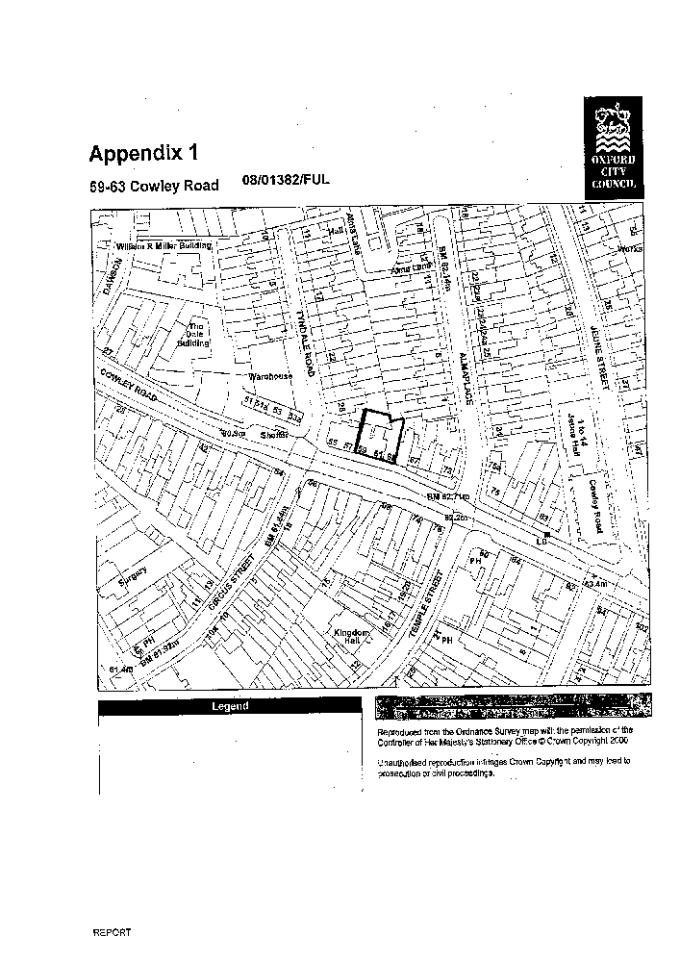

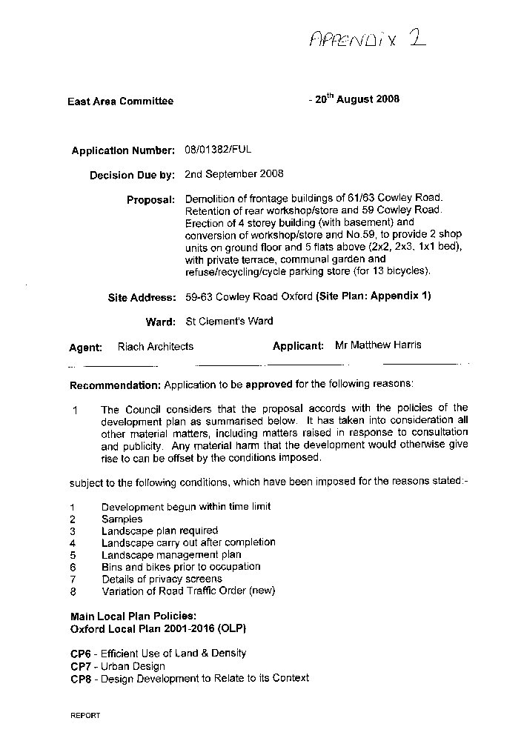
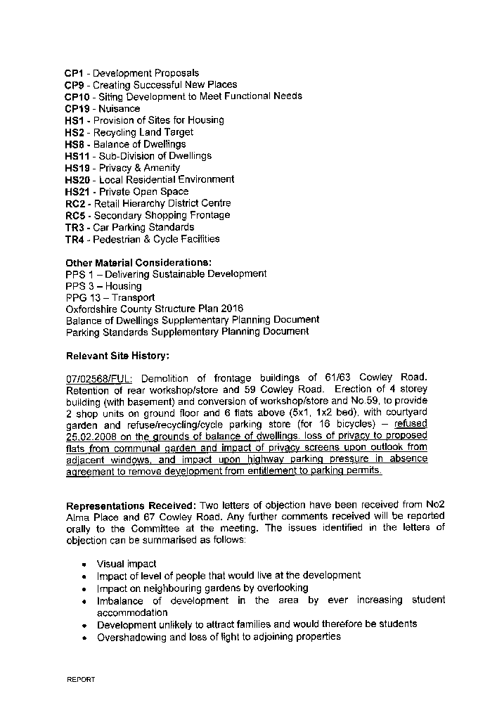
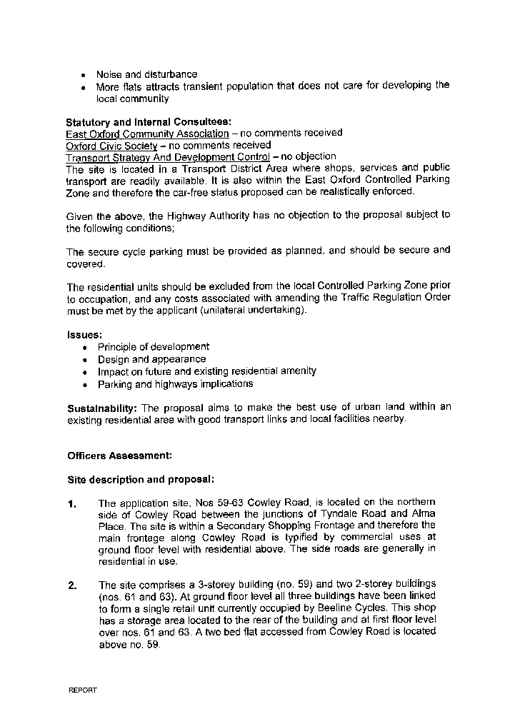
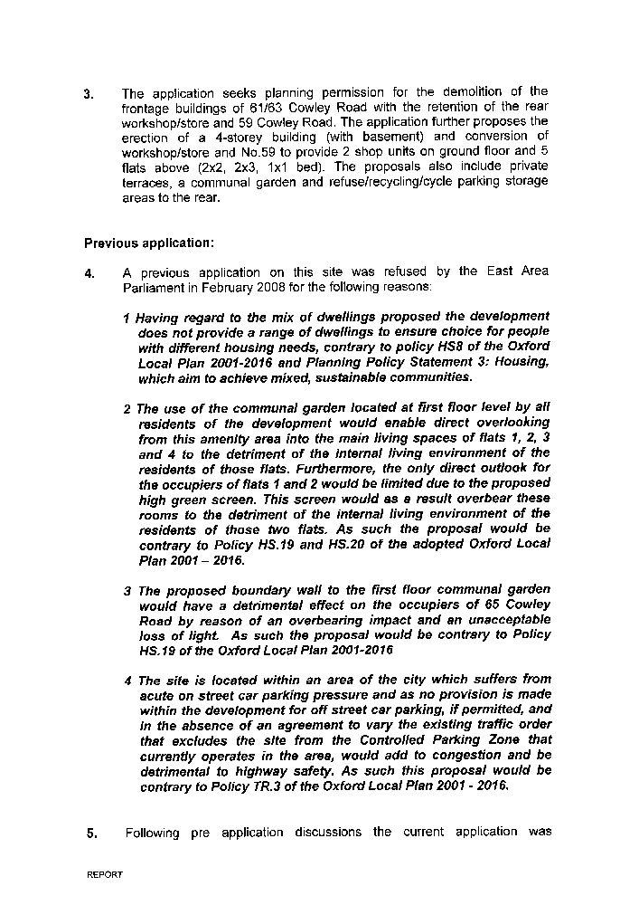
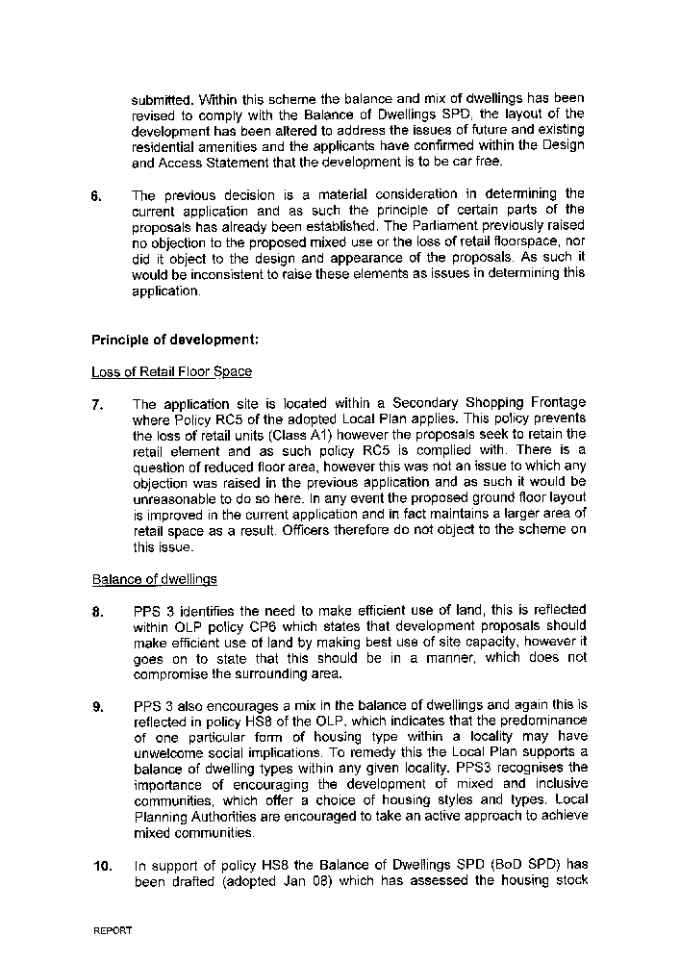
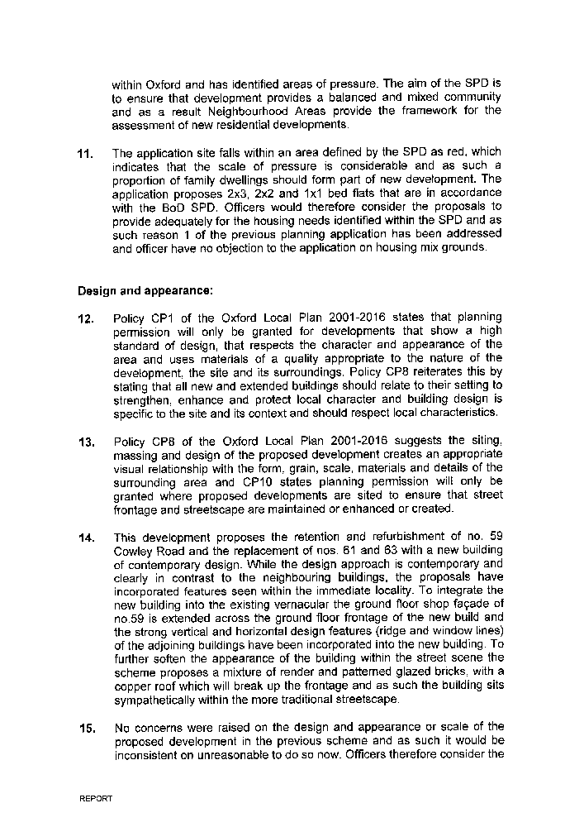
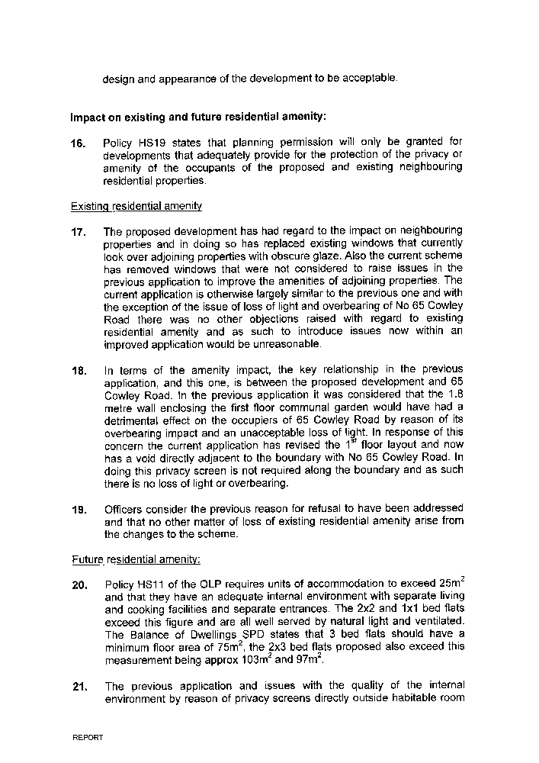
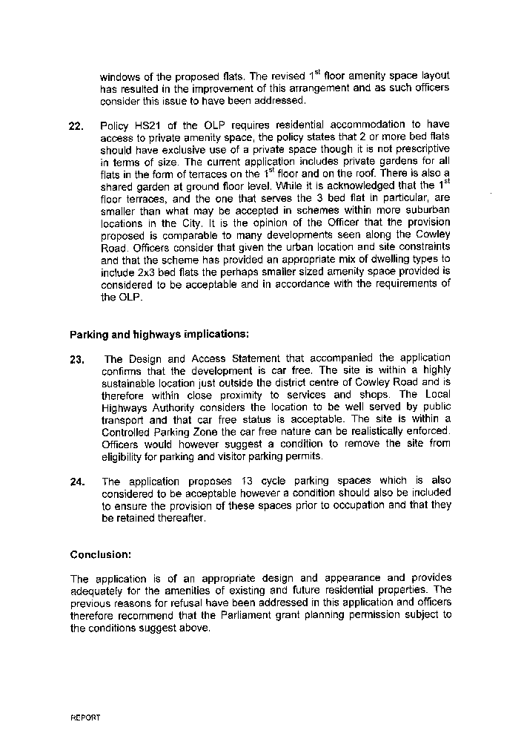
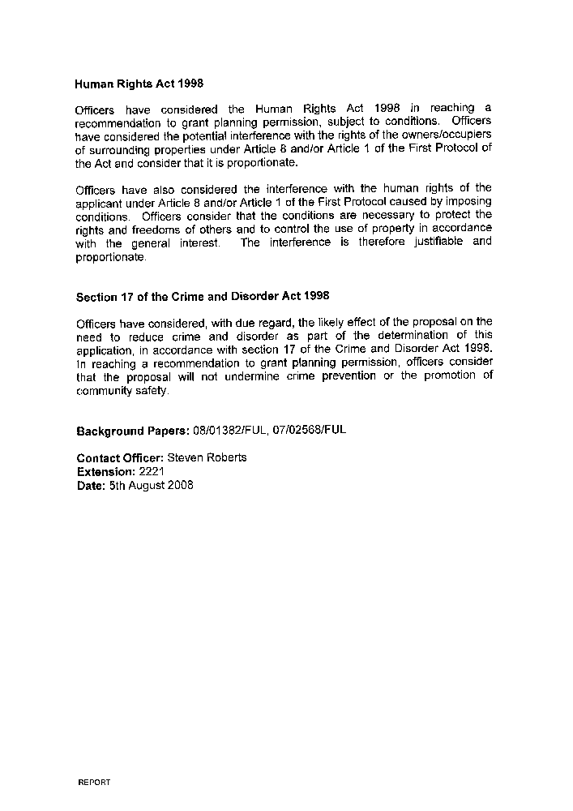
APPENDIX 3

Town and Country Planning Act 1990

Appeal by Mr Matthew Harris against the decision of Oxford City Council to refuse planning permission for the demolition of frontage buildings of 61/63 Cowley Road. Retention of rear workshop/store and 59 Cowley Road. Erection of 4 storey building (with basement) and conversion of workshop/store and No.59, to provide 2 shop units on ground floor and 5 flats above (2x2, 2x3, 1x1 bed), with private terrace, communal garden and refuse/recycling/cycle parking store (for 13 bicycles), at 59-63 Cowley Road, Oxford.

Local Planning Authority Reference: 08/01382/FUL

Planning Inspectorate Reference: APP/G3110/A/08/2089022/WF

Written Statement of the Local Planning Authority
- Appeal Site and Locality

  - The appeal site, No 59-63 Cowley Road is identified on the attached site plan (appendix 1). It is located approximately ½ a mile to the east of Oxford city centre within the St Marys ward. Cowley Road is a commercial centre with retail and business units primarily at ground floor with a mix of residential and office space on the upper floors. While the site and its immediate locality is commercial, the Cowley Road is sandwiched between residential development to the north and south and as such does not have a typically urban quality that one would expect from a location such as this. This is typified by the scale and appearance of the buildings along with the uses find at ground floor level. The site is also located with the St Clements and Iffley Conservation Area.

  - The site comprises a 3-storey building (no. 59) and two 2-storey buildings (nos. 61 and 63). At ground floor level all three buildings have been linked to form a single retail unit currently occupied by Beeline Cycles. This shop has a storage area located to the rear of the building and at first floor level over nos. 61 and 63. A two bed flat accessed from Cowley Road is located above no. 59.

- Relevant Planning History

  - The following applications are considered relevant to the appeal:

07/02568/FUL: Demolition of frontage buildings of 61/63 Cowley Road. Retention of rear workshop/store and 59 Cowley Road. Erection of 4 storey building (with basement) and conversion of workshop/store and No.59, to provide 2 shop units on ground floor and 6 flats above (5x1, 1x2 bed), with courtyard garden and refuse/recycling/cycle parking store (for 16 bicycles) – refused 25.02.2008 on the grounds of balance of dwellings, loss of privacy to proposed flats from communal garden and impact of privacy screens upon outlook from adjacent windows, and impact upon highway parking pressure in absence agreement to remove development from entitlement to parking permits.

The Application and Proposal

The appeal relates to the demolition of the frontage buildings of Nos 61/63 Cowley Road. The erection of 4 storey building (with basement) and conversion of the retained workshop/store and No.59 Cowley Road, to provide 2 shop units on ground floor and 6 flats above (5x1, 1x2 bed). The proposals include a courtyard garden at ground floor level along with refuse/recycling and cycle parking storage for 16 bicycles.

The application submitted was received and registered by Oxford City Council on the 8th August 2008 and was assigned the reference No 08/01382/FUL. Receipt of the application was advertised in the City Councils weekly list of planning applications received and the Local Planning Authority consulted local residents inviting comments by the 2nd August 2008. Two letters of representation were received and these were copied with the council’s questionnaire.

In accordance with the Councils Constitution the application was reported to the East Area Parliament on the 20th August 2008. Planning permission was then refused on the 29th August 2008 for the following reasons:

1. The proposed building due to its design and, in particular, its height and roofing materials, fails to relate to the context of the surrounding area and is out of keeping with the character, appearance and grain of the local urban fabric and is therefore detrimental to the visual amenities of the locality. As such the development is contrary to policy CP8 of the Oxford Local Plan 2001 - 2016.

2. The proposed building due to its orientation, design, size and position in close proximity to both the boundary, gardens and the adjacent residential dwellings themselves will unacceptably enclose and have an overbearing impact on the amenity of residents of Alma Place contrary to policy HS.19 of the Oxford Local Plan 2001-2016.

A copy of the decision notice was attached with the council’s questionnaire.
- Relevant Planning Policy

Oxford Local Plan 2001 – 2016 (OLP)

4.1 The application was assessed against the policies within the Oxford Local Plan 2001 – 2016 (OLP). The OLP contains the following policies applicable to this appeal:

CP1 - Development Proposals
CP9 - Creating Successful New Places
CP10 - Siting Development to Meet Functional Needs
CP19 - Nuisance
HS1 - Provision of Sites for Housing
HS2 - Recycling Land Target
HS8 - Balance of Dwellings
HS11 - Sub-Division of Dwellings
HS19 - Privacy & Amenity
HS20 - Local Residential Environment
HS21 - Private Open Space
RC2 - Retail Hierarchy District Centre
RC5 - Secondary Shopping Frontage
TR3 - Car Parking Standards
TR4 - Pedestrian & Cycle Facilities

Copies of all the Local Plan policies and the supporting text are attached to the questionnaire.

Adopted Oxfordshire Structure Plan 2016

4.2 Policy G1 states, “The general strategy is to provide a framework for development to sustain economic prosperity, meet housing and other requirements and guide the investment decisions of a range of organisations for the period of 2016 in ways which will:

- deliver the level of development required to meet the objectives of this Plan while protecting and enhancing the environment, character and natural resources of the county;

- concentrate development in locations where;

  - a reasonable range of services and community facilities exist or can be provided; and
  - the need to travel, particularly by private car can be reduced and walking, cycling and the use of public transport can be encouraged;

- make best use of previously developed land and buildings within urban areas to reduce the need for the development of Greenfield sites, while not permitting development on important open spaces.

The larger urban areas will be the main focus for development……..”

4.3 Policy G2 states that all development should;

  - be of a scale and type appropriate to the site and its surroundings, and not cause harm to the character and amenities of the areas;
  - incorporate a high quality of layout, design and landscaping; and
  - be designed so as to reduce the need to travel and encourage the use of walking, cycling and public transport and telecommunications as alternatives to the car.

Development which would have an unacceptable impact on the environment because of its scale, location or cumulative effects will not be permitted”.

Balance of Dwellings Supplementary Planning Document
  - Having regard to the emphasis put on developing mixed and inclusive communities and offering a choice of housing styles and types in PPS3 and policy HS8 of the OLP the Balance of Dwellings SPD (BoD SPD) has been written (adopted Jan 08). This SPD takes a strategic approach and aims to ensure that development provides a balanced and mixed community.

National Planning Guidance
  - Planning Policy Statement 1: Delivering Sustainable Development sets out the Governments national policy on the principles of sustainable development. It suggests that good design should be integrated into the existing urban form and while not being prescriptive with regard to architectural style does suggest that the scale, massing and layout of developments must be appropriate to the site and wider context. The document states that design which is inappropriate in its context, or which fails to take the opportunities available for improving the character and quality of an area and the way it functions, should not be accepted.

  - Planning Policy Statement 3: Housing sets out the national planning policy framework for delivering the Governments housing objectives. PPS3 promotes the efficient use of land but stresses that this should not be to the detriment of visual or residential amenity. It suggests that development should be integrated with, and complement, the neighbouring buildings and the local area more generally in terms of scale, density, layout and access.

- The Case of the Local Authority
  - The appeal application was refused for two reasons as set out above. The Council will expand on each reason separately but in the first instance would take this opportunity to respond to the comments made in the Appellants Statement regarding the alleged inconsistency between the previous application and the one subject to this appeal.
5.2 This appeal application increases the roof height slightly and this coupled with the change in the shape of the roofline from that of the previous application led to the introduction of the design concerns that formed part of the refusal of the appeal scheme. The shape and the height of the roof had in fact been discussed on the previous application and therefore the appellants need not be surprised that, with the extra height and changed appearance, this became a material consideration in the Committee’s discussion of the new application. The Committee did not seek to obstruct consent as is stated in the appellants statement but considered carefully all aspects of the changed application.
  - There was also still a concern that the application was contrary to the Councils Balance of Dwellings Supplementary Planning Document and policy HS8 of the Oxford Local Plan. Also that the proposals would constitute the loss of one of the few larger retail spaces (albeit the proposals did retain two smaller units) with loss of the generous storage space that is at the moment on the first floor as well as the ground floor. Concerns was raised that the probability is that the two smaller units with less storage will become take-away outlets of which there are already numerous outlets along Cowley Road.
5.4 However, the Committee felt that the real problem, rather like the straw that broke the camel’s back, was the extra height that is not sufficiently set back in the appeal application and would be detrimental to the overall view of the area as well as creating a significant added impact on the houses to the rear in Alma Place and could, as a result, not give consent.

Reason 1

5.5 The appellant’s statement describes the Cowley Road frontage as merely a multi-cultural and commercial artery leading in to the centre of Oxford. This was perhaps the character of the road before the regeneration scheme and redesign of the last decade. But, since that redesign, the Cowley Road has become one of the iconic roads of Oxford, in the sense that although it is ‘Town’ rather than ‘Gown’, it is beloved of students of both universities, as well as the local residents.

  - While the appellants are correct to use the term ‘urban’ in describing Cowley Road this is far too generic assessment and its character is not a typical urban one. It was developed over the years as a road of small, varied and alternative, shops set in a backdrop of low, two and three storey houses. Its charm lies in this homely mixture of houses and small popular businesses and shops and now, rather than being seen as an arterial through road, it is recognised as a community and locality that is much treasured for its special character and human scale.

  - At this end of the road it joins two other roads (St Clements Street and Iffley Road) that are within the St Clements and Iffley Road Conservation Area. It is quite noticeable that this end of the Cowley Road has a quieter and more orderly character and not the ‘apparent chaos of commercial activity’ of the appellants description. That might be said of the far end of the road, but even that has the overall framework of low terraces of older houses and has a certain order.

  - The City end of the Cowley Road is not characterised by 4 storey buildings but rather by two and 3 storey buildings, some of them, as in the neighbouring house, with the original windows and very much unaltered. If anything, it is the design of the appeal scheme that is chaotic, with a fenestration different than that of the first application that has no regard to the grain of the adjoining buildings.

  - The design of the proposed building is quite out of keeping with the early part of the road in its height as a four-storey building as well as in its style. The roofline is significantly higher and, although slightly set back, is not sufficiently set back not to be noticed from the other side of the street nor to anyone approaching along that side.

  - The appellants quote the use of this copper roofing material in the Islamic Centre on the Marston Road. That building is indeed a monumental building standing on its own and is really a prestigious and flamboyant building of quite different character and in a completely different context than this proposed building and as such not comparable to this appeal, which would sit in a terrace of simple brick and slate residential houses.

  - The style of the roof and material used really is too strong a statement for this point on the Cowley Road and would not only draw attention to the difference in height and roofline but the curved roof in the copper material would have a jarring effect.

  - In neither the form nor the materials would the proposed building be integrated or sit well within its context of close connected low buildings in brick and slate. The design would not create an appropriate visual relationship with the terrace of houses which so closely adjoin it and would not sit comfortably in that context.

Reason 2

  - The roofline of the new development is higher than the present building and would, from the rear have a disproportionate effect on the gardens and back outlook of the low terrace of family houses that comprise Alma Place. It is not consistent with the existing conditions of the area. The gardens of Alma place are enjoyed by their residents and this building would certainly have an overbearing effect on them.

  - The angles of the buildings and the complexity of sun shading at different times of year can perhaps really only be accurately understood by a site visit and by those who live there and have good experience of the position of the sun in relation to their gardens over those different times of year. But the Council would suggest that a site visit to one of those small gardens would give a proper sense of overbearing and the disproportionate effect of the higher roofline of this larger building.

  - The scale of the building coupled with the use of materials would have an overbearing visual impact upon the Alma Place properties that would be harmful to the amenities of those residents.

Summary

  - The Council do not oppose a well integrated new development in this position but maintain the view that this particular proposal does not comply with policy CP8 of the Oxford Local Plan in that it would not be well integrated with the adjoining buildings. It would be out of keeping with the simple and traditional style and materials of the adjoining buildings and be discordant with this part of the Cowley Road. In addition the development would create a sense of enclosure in the properties to the rear and would have an overbearing impact on their modest but pleasant gardens.
6.2 It is not considered that anything raised in the grounds of appeal introduces any issue that justifies allowing this development and the inspector is respectfully requested to dismiss the appeal. However should the Inspector be minded to allow the appeal the Council would suggest attaching the following conditions:

1 The development to which this permission relates must be begun not later than the expiration of three years from the date of this permission.

Reason: In accordance with Section 91(1) of the Town and Country Planning Act 1990 as amended by the Planning Compulsory Purchase Act 2004.

2 Samples of the exterior materials to be used shall be submitted to, and approved in writing by, the Local Planning Authority before the start of work on the site and only the approved materials shall be used.

Reason: In the interests of visual amenity.

3 A landscape plan shall be submitted to, and approved in writing by, the Local Planning Authority before development starts. The plan shall include a survey of existing trees showing sizes and species, and indicate which (if any) it is requested should be removed, and shall show in detail all proposed tree and shrub planting, treatment of paved areas, and areas to be grassed or finished in a similar manner.

Reason: In the interests of visual amenity.

4 The landscaping proposals as approved by the Local Planning Authority shall be carried out in the first planting season following substantial completion of the development if this is after 1st April. Otherwise the planting shall be completed by the 1st April of the year in which building development is substantially completed. All planting which fails to be established within three years shall be replaced.

Reason: In the interests of visual amenity.

5 A landscape management plan, including long term design objectives, management responsibilities and maintenance schedules for all landscape areas, other than small, privately owned domestic gardens, shall be submitted to, and approved in writing by, the Local Planning Authority prior to the occupation of the development or any phase of the development, whichever is the sooner, for its permitted use. The landscape management plan shall be carried out as approved.

Reason: In the interests of amenity and the appearance of the area.

6 The development hereby approved shall not be occupied until the areas for the storage of bins and bicycles have been constructed in strict accordance with the approved plans.

Reason: In the interest of residential amenity

7 Prior to work commencing on site details of the privacy screens to be erected on site (height and materials/appearance) shall be submitted to and approved in writing by the Local Planning Authority. The approved screens shall be in place prior to occupation of the development.

Reason: In the interests of residential amenity

8 The development hereby permitted shall not be occupied until the Order governing parking at 59-63 Cowley Road has been varied by the Oxfordshire County Council as highway authority to exclude the site, subject to this permission, from eligibility for resident's parking permits and residents' visitors' parking permits unless otherwise agreed in writing by the Local Planning Authority.

Reason: To ensure that the development does not generate a level of vehicular parking which would be prejudicial to highway safety, or cause parking stress in the immediate locality.

